

Understanding The 7 Chakras

The Root Chakra
The Sacral Chakra
The Solar Plexus Chakra
The Heart Chakra
The Throat Chakra
The 3rd Eye Chakra
The Crown Chakra

The entire universe is made of energy, and your body is no exception.
Long before modern technology and science, ancient cultures knew that all living things carried a life force with them. They called the centers of energy that move inside of us, the 7 chakras. So what are the seven chakras?
Chakra is an old Sanskrit word that literally translates to wheel.
This is because the life force, or prana, that moves inside of you is spinning and rotating. This spinning energy has 7 centers in your body, starting at the base of your spine and moving all the way up to the top of your head.
In a healthy, balanced person, the 7 chakras provide exactly the right amount of energy to every part of your body, mind and spirit.
However, if one of your chakras is too open and spinning too quickly, or if it is too closed and moving slowly, your health will suffer.

By learning about the 7 chakras, you can become more in tune with the natural energy cycles of your body. You can use this information to connect physical, emotional and spiritual imbalances with the chakras that empower them. Of course, with those discoveries you can begin to balance your chakras and live a healthy and harmonious life.
Before diving right into learning about the seven chakras and what each of them do, take a moment now to tune in to your body and see if you can feel your chakras at work. For beginners, those chakra exercises may seem "odd" - simply go with the flow and soon, you will not be a chakra beginner any longer.
You may sense the prana energy centers very lightly, very intensely or not at all. Whatever happens is ok.
Think of this exercise like an introduction; you're tuning in for, perhaps, the very first time...

Time to get started...
- First, start by making sure you're in a quiet space. If you can't be right now, just return to this section of the article later. But if you can, sit quietly for a moment and take a few deep breaths. Let tension and stress slide away for just a moment. Just be in the moment, with your body.
- Now, bring your attention to the base of your spine, your tailbone, and imagine a bright spinning red light. Feel it pulsing and rotating with your breath. Sit with that for a moment.
- Move your attention up your spine to the area a couple of inches below your belly button. Feel the warmth of a bright, orange spinning light. Again, notice how it moves with your breath.
- Guide your attention further up to a couple inches above your belly button. You're probably familiar with this area, because when you feel strong emotions like love or fear, you likely feel it here. Notice how you can sense the intense yellow light rotating in that spot.
- Bring your attention further up to the center of your chest where your heart is. This area harnesses a bright green light. When you're touched or moved, you might instinctively place your hand over this spot. Connect with that area now.
- Then, bring your attention to your throat, the dip in between your collar bones. Imagine a bright blue light spinning in that area.You may feel the urge to swallow or clear your throat as you think of it.
- Next, move your attention up to the space on your forehead between your eyebrows, your third eye. This area holds a deep indigo rotating light. Imagine yourself becoming wiser as it spins and becomes brighter.
- Finally, shift your attention to the very top of your head. Imagine a vibrant, spinning violet light that shines right out of the top of your body. This light connects you to the universe. Feel the peace that comes with noticing this light.

The Seven Chakras: Meaning and Symbols

Now that you've been introduced to your chakras, let's talk about the role that each of them plays in your life.

We're going to discuss the location and purpose of each chakra, and we'll also talk about the symptoms you might experience when they are balanced or imbalanced. Of course, each discussion will conclude with how to heal, empower or tame each chakra.
- The Root Chakra
- The Sacral Chakra
- The Solar Plexus Chakra
- The Heart Chakra
- The Throat Chakra
- The 3rd Eye Chakra
- The Crown Chakra


The 1st Chakra - Root Chakra - Muladhara
The official name of this chakra, muladhara, comes from the words Mula, which means root and Dhara, which means support. So, this chakra's role is to connect all of your energy with the Earth, which is called grounding.
When you think of your Root Chakra, think of your day to day survival here on earth. This energy center's role is to give you everything you need to survive. For us in this modern age, that typically translates to financial and emotional security.

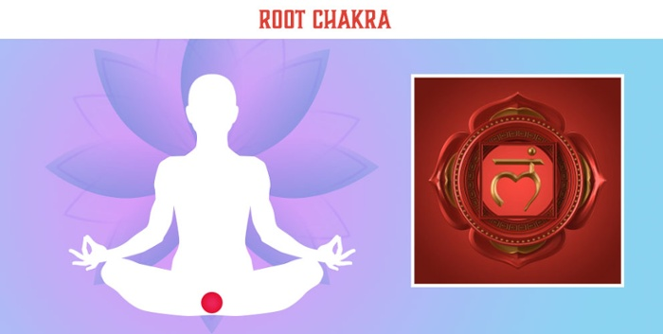

Color: Red
Location: This chakra is located at the very base of your spine, near your tailbone. It goes up to just below your belly button.

What balanced feels like: When your 1st chakra is balanced, you will feel a sense of accomplishment and peace when you think about things like money, safety and shelter.
You will feel connected to your human experience.

When this chakra is overactive: Our root chakra gets a lot of use, so having an overactive one is very common.

When is your 1st chakra overactive?
An overactive root chakra will cause problems like anxiety and jitteriness. This happens because fear is based out of the need to survive. That is fear's role - to keep us alive.
So, an overactive root chakra will shout messages of survival, even when no real threat is there; thus, you will have anxiety problems. Physically, you might have symptoms of digestive problems, lower back issues, hip pain, ovarian cysts in women or prostate issues in men.

How to balance your 1st chakra
In practical terms, it's important to take care of your survival needs first. This chakra gives you the energy to do that, so utilize that energy to the best of your ability.
Then, calm this chakra by focusing on your connection to spirit. Take time each day to nurture your soul by praying, meditating or connecting to spirit guides.
Volunteering and acts of kindness and compassion can guide overactive energy away from your root chakra and into other energy centers in your body.

When is the 1st chakra underactive
If your survival needs have generally been taken care of, this chakra may not have been very active throughout your life. If that's the case, you may experience frequent day dreaming, trouble concentrating or simply feeling like your "head's in the clouds." People may say you appear "airheaded" or "spacey."
These may not seem like major issues, but being balanced and connected is important.

Energize your 1st chakra
If you find yourself disconnected from material existence, your 1st chakra may need to be revved up.
You can do this with reconnecting to the earth by being out in nature. Gardening, swimming or even playing in the leaves can energize your root chakra.

The 2nd chakra - Sacral Chakra - Svadhishana
The 2nd chakra is the sacral chakra or svadhishana, which translates to "the place of the self." This chakra is all about your identity as a human and what you do with it. This chakra brings you creative energy to enjoy life.
Your sacral chakra is the home of the creative life force energy that helps you enjoy your life here on Earth.
It's the energy that motivates you to enjoy the fruits of your labor including indulging in pleasurable activities like sex.
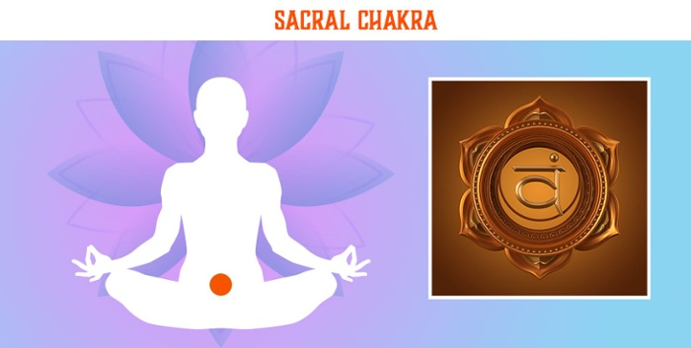
Color: Orange
Location: The sacral chakra is located right below the belly button and extends to its center.

What balanced feels like: When your 2nd chakra is balanced, you will relish in the pleasurable things life has to offer, without overdoing them. Sex, good food and creative activities will be inspiring and enjoyable, and you will get a sense of wellness and abundance from them.

When this chakra is overactive
The sacral chakra is often overactive when we face things like addiction and gluttony. Pleasure is a good thing, and you should never feel guilty for enjoying the good things life has to offer.
However, if you find yourself enjoying things that aren’t nourishing for your soul or healthy for you, then your sacral chakra is likely out of balance. Symptoms include addiction, obesity, hormone imbalances and restlessness.

How to balance your 2nd chakra
To balance your 2nd chakra, it’s helpful to draw energy away from pleasure and into your heart.
You can do this by asking yourself a simple question before each action you take. Ask yourself, “Is what I am about to do good for me? Is it healthy and nourishing? What are the benefits of the action I’m about to take? ” Taking time to assess whether your actions are healthy is a great way to draw energy away from this chakra.

When this chakra is underactive
If you’ve spent a lot of time focusing on very practical things without enjoying the fruits of your labor, your sacral chakra may be underactive. Symptoms of this include depression, impotence, decreased sex drive and a lack of passion and creativity.

How to energize your 2nd chakra
Energizing your 2nd chakra is fun. In simple terms - enjoy life! Create a piece of art. Eat a healthy and enjoyable snack. Make love to your partner.
Take time for yourself and enjoy the incredible gifts the Earth has to offer you.

The 3rd chakra - Solar Plexus - Manipura
The 3rd chakra is the Solar Plexus or Manipura, which translates to “lustrous gem." This chakra is where your self-confidence, identity and personal power are born.
Have you ever been in a situation that you just knew wasn’t right for you?
Perhaps you’ve been in a situation that you knew was going to work out. Where did you feel those cues in your body? Most people say they feel those types of cues in their “gut.”
In reality, this is the seat of your personal power, your solar plexus, and you can physically feel that confidence and wisdom in its location.
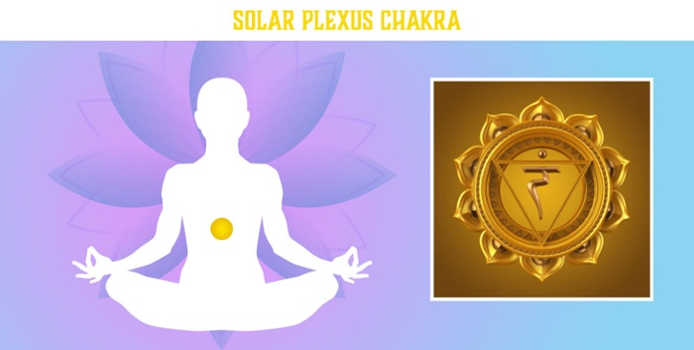
Color: Yellow
Location: The solar plexus starts in the center of the belly button and extends up to the breastbone or where your two sets of ribs connect in the center of your chest.

What balanced feels like: When your 3rd chakra is balanced, you will feel a sense of wisdom, decisiveness and personal power. Many call this chakra the warrior chakra, as the feeling you get from it is comparable to a wise warrior going into battle.
He has the confidence to win and the wisdom to know the personal truth he is fighting for.
When this chakra is overactive
The solar plexus chakra becomes overactive when the power we have over our own lives extends into the lives of others. When this chakra is too energized, you may feel quick to anger, the need to control and micromanage, greediness and a lack of compassion or empathy.
You may suffer from digestive issues or even imbalances in your internal organs like the appendix, pancreas, liver and kidneys.

How to balance your 3rd chakra
To balance your 3rd chakra, practice opening up your heart with love and compassion. Meditate on sending love and kindness from your heart to all those around you. Refocus the power you have and see yourself as a beacon of love.

When this chakra is underactive
When our personal power is taken away from us either by another person or through extenuating circumstances, we may be left with a lack of energy in our 3rd chakra. When this happens, you may feel indecisive, insecure, timid and needy.

How to energize your 3rd chakra
To energize your Solar Plexus, think of the things that you know you’re good at. Everyone has talents and abilities.
Make a list of yours. Feel how the confidence in those talents makes your stomach tingle and vibrate. Empower that feeling by creating your own personal affirmations.

The 4th chakra - Heart - Anahata
The 4th chakra is the Heart or Anahata chakra, which translates to “unhurt." This chakra is where your love, compassion and kindness are empowered. It's not hard to understand this chakra.
We all associate our hearts with love, and that's exactly what the 4th chakra is all about. This includes love for others and love for yourself, which is why this chakra is also associated with health and healing.
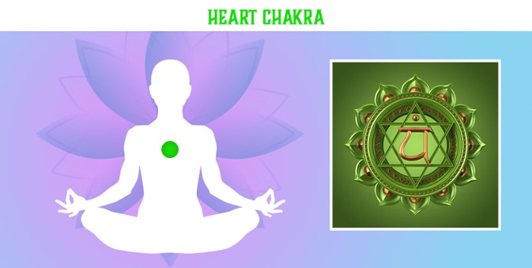
Color: Green
Location: The heart chakra's center is located right over your heart and it radiates down to your breastbone and up to your throat.

What balanced feels like: When your 4th chakra is balanced, you are able to equally feel love for yourself and others. Even when tough things happen, you can still see the compassion and kindness in others.

When this chakra is overactive
When the heart chakra becomes overactive, we lose our personal boundaries and start to make unhealthy choices, all in the name of love.
It's important to treat yourself with the same compassion and kindness that you give others, but when the heart chakra is overactive, you may find yourself always putting the needs of others before your own. Symptoms include a fast heart rate, palpitations, heart burn and interpersonal relationship issues.

How to balance your 4th chakra
Balancing your 4th chakra means taking that love you've given to others and focusing some of it back on yourself. You can do this by doing 1 thing every day that's just for you:
- Take a relaxing bath
- Treat yourself to a massage
- Meditate on sending compassion to yourself

When this chakra is underactive
Many people have an underactive 4th chakra. Life can send us a lot of heartbreak as a way to teach us lessons about ourselves and the world around us. But, it can be hard to not take those lessons personally. When your heart chakra is underactive, you will feel like it's hard to get really close to anyone. It's like building a wall around your heart and not letting anyone in. Physically, you may feel out of touch with your body and suffer from circulation problems.

How to energize your 4th chakra
Energizing your heart chakra may take a lot of work.
Many of us have worked hard to build up our walls and defenses, and it isn't always easy to knock them down. It first begins by loving yourself.
Show appreciation for yourself, and give yourself the love that you want others to give to you. Then, spread that compassion to those around you.

The 5th Chakra - Throat - Vishuddha
The 5th chakra is the Throat chakra or Vishuddha which translates to “very pure."
This chakra gives a voice to your personal truths. Where does your voice come from?
What provides the energy for you to speak?

On a physical level, of course the answer is the throat, but on an energetic level, this energy actually comes from your 5th chakra. This chakra lets you speak your truth with clarity.
Resting right above the heart, the throat chakra is connected to the compassion and love you have for yourself and others.
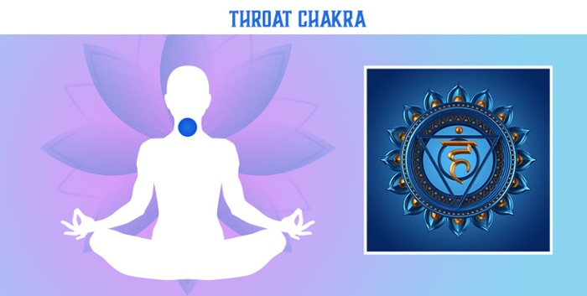
Color: Blue
Location: The throat chakra’s center is right in between your collar bone, and it radiates down to the center of your heart and up to the center of your eyes.

What balanced feels like: When your throat chakra is balanced, you will be able to clearly speak with love, kindness and truth. You will know exactly which words are appropriate for each situation. Speaking with a balanced throat chakra will enlighten and inspire those around you.

When this chakra is overactive
Our 5th chakra becomes overactive when we’ve spent a lot of time trying to make our voice heard.
If you’ve often felt ignored or invalidated when you express yourself, you may have tried to overcome this by giving yourself a louder voice.
Those with overactive throat chakras will often interrupt others, often be told they have a loud voice or “love to hear themselves talk.” Physically, you may suffer from throat pain, frequent infections, cavities or mouth ulcers.

How to balance your 5th chakra
Balancing your 5th chakra is as easy as thinking before you speak.
Take it from the Buddha, before you say anything, ask yourself:
“Is it true? Is it necessary? Is it kind?”

When this chakra is underactive
Sometimes, we have been ignored and invalidated so much that we react in an opposite way - we shut down our voices and never speak our truth.
If you have an underactive throat chakra, you have likely been called shy or quiet. You may find yourself unable to express your emotions or struggling for words when you try to speak your truth.
Physical symptoms often include digestive issues, because energy diverted away from the throat chakra often ends up being “swallowed” or sent down to the 3rd chakra.

How to energize your 5th chakra
Speak your truth!
Even if no one is around to hear you, practice expressing your emotions and truths when you’re alone. It’s very common to think that we should only speak when someone else is around to hear it, but if you’re trying to energize your third chakra, it doesn’t matter if its received by any other ear than your own.

The 6th Chakra - The Third Eye - Ajna
The 6th chakra is the Third Eye or Ajna which translates to “beyond wisdom.” This chakra opens up your mind to information beyond the material world and the 5 senses.
Extra sensory perception, intuition or psychic energy, all comes from the third eye.
There is actually a small pinecone shaped gland in your brain that takes in light. This gland, the pineal gland, is responsible for helping you feel awake in the daytime and sleepy at night.
Long before brain imaging, ancient cultures knew this Third Eye existed, and they also realized that it receives information from sources outside of the five senses.
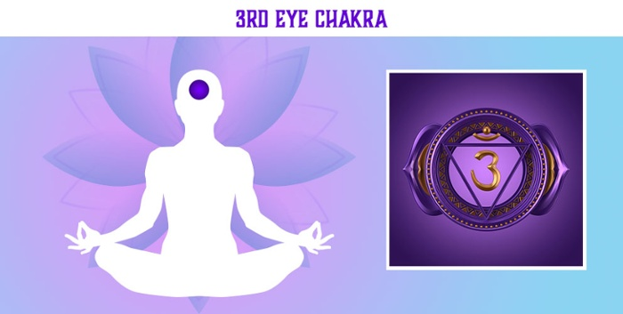
Color: Indigo
Location: The third eye’s center is in between your eyebrows. It radiates down to your mouth and up to the top of your head.

What balanced feels like: A balanced third eye is a beautiful thing, and it’s really what you are trying to achieve when you start on a path to spiritual development.
When your third eye chakra is balanced, you will equally feel in tune with both the physical world and the material world. You will receive psychic information as frequently as you receive information from your 5 physical senses, but it will not overwhelm you.

When this chakra is overactive
It is very unlikely your 6th chakra is overactive.
Most of us are very in tune with our physical reality and find it difficult to receive information outside of it. That being said, if you have an overactive third eye, you likely spend most of your time engrossed in psychic activities like tarot card readings, astrology and paranormal experiences.
When your 3rd eye chakra is overactive, those activities become overwhelming and distract you from living a human experience.

How to balance your 6th chakra
If you find yourself consumed with psychic information, take some time to remind yourself that you are a creature of the Earth.
Go to the beach and feel the sand on your toes. Dig your in the dirt in your garden. Connect your body to Earth and repeat: “I am a human being. I am a human doing.”

When this chakra is underactive
Most people have an underactive 6th chakra.
We live in a world that often invalidates intuitive development.
Because of this, we close off our Third Eyes and ignore our own psychic experiences. Doing so can cause us to feel disconnected from spiritual experiences. Physically, you may feel headaches or have problems with allergies and your sinuses.

How to energize your 6th chakra
Energizing your third eye will take some practice. You’ll need to devote some time to quiet, solitary meditation. At first, get used to the feeling of focusing on signals outside of your physical body.
Listen to your spirit and recognize how that feels. As you practice this, you’ll find it easier and easier to connect with the energy from your Third Eye.

The 7th Chakra - Crown - Sahaswara
The 7th chakra is the Crown or Sahaswara, which translates to “thousand petaled.” This chakra is pure consciousness energy. The Crown chakra is one of those energies that’s hard to explain.
You can think of it like magnetism. When you hold a piece of metal to a magnet, you can feel the energy and tension, but you can’t see it. Consciousness energy is everywhere and in everything. It connects us to the entire universe.
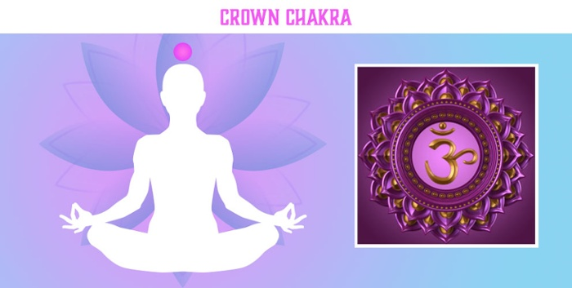
Our own personal consciousness is located in the 7th chakra, but it’s really more like the seed of a universal energy than something personal or individual.
Color: Violet - White

Location: The crown chakra’s center is at the top of your head. It radiates down to between your eyes and then extends infinitely upward and outward, connecting you to the energy of the rest of the universe.

What balanced feels like: Achieving a balanced crown chakra is the goal of every spiritual warrior, and it’s not easy to do. You can think of it like the Buddhist concept of achieving nirvana.
Once you achieve it, you’re not really human anymore - you’ve conquered suffering and death.
Of course, it is the journey of attempting to achieve this balance that brings us happiness, good health and wisdom. Trying to balance your 7th chakra will align and balance your other chakras.

When this chakra is overactive
It’s not possible to have an overactive crown chakra.
Because it is the seat of universal energy, it is innately infinite. In other words, you can’t exist in the material world and be overcome with consciousness energy.

How to balance your 7th chakra
Since no one has an overactive crown chakra, there’s no need to consider how to calm the energy down.

When this chakra is underactive
An underactive 7th chakra means you’re human.
It feels exactly like being a human. Some people may be closer to achieving it, while others may be far away. In any case, practicing spiritual development and balancing your other chakras will bring your closer to experiencing the consciousness energy in your crown chakra.

How to energize your 7th chakra
Instead of attempting to open up and active your crown chakra, focus on balancing the other 6 chakras. Meditate and connect with spirit and balance those activities with living and enjoying your human experience. Think of it like trying to win an Olympic gold medal. You don’t just try to win the medal, you train your body and mind first. The only way to achieve such a huge goal is to focus on small, attainable goals first.The same goes for trying to open your crown chakra. Don’t just attempt it; focus on maintaining and balancing all the other energies in your body.

