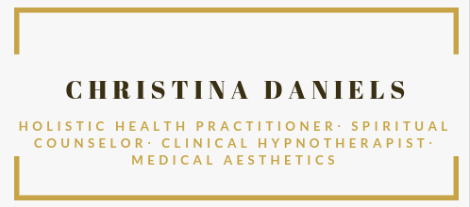

Date:_________

I consent to my child’s participation in hypnotherapy/Spiritual Counseling/ Holistic Health Consultation and care by Christina Daniels, Clinical Hypnotherapist/Spiritual Counselor/Holistic Health Practitioner/NLP Practitioner.

My Child’s name is: ______________________.

Signed: ______________________________(parent/guardian)

Print: _______________________________(parent/guardian)

Address:
________________________________________________________

________________________________________________________

________________________________________________________

________________________________________________________

Day phone: _________________

Evening Phone: _________________

